**E-STEAMSEL PROJECT**

**Erasmus+ KA2-** **NO: 2021-1-NO01-KA220-SCH-000032511**

E-STEAMSEL TRAINING PROGRAMME

**SEL (SOCIAL EMOTIONAL LEARNİNG)**

**Social and Emotional Learning Framework**

**Project Identification**

Programme: Erasmus+ Action: Strategic Partnerships for School

Project Title: **E-STEAMSEL Preparing Youth for the Future Labor Market with STEAM and SEL**

Number:**Erasmus+ KA2-** **NO: 2021-1-NO01-KA220-SCH-000032511**

Project Acronym: E-STEAMSEL

Project Start Date:

Project Total Duration: 24 months

Project End Date:

**Project’s Partners**

  

  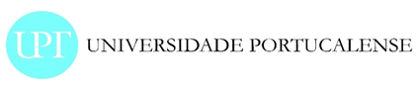

**Social and Emotional Learning Philosophy**

“We live in a global economy that requires our students to be prepared to think both critically and creatively, evaluate massive amounts of information, solve complex problems, and communicate well. A strong foundation in reading, writing, math, and other core subjects is still as important as ever, yet by itself is insufficient for lifelong success. For too long, we have committed to time structures, coursework, instructional methods, and assessments designed more than a century ago. Our current definition of student success is too narrow. It is time to put students first, align resources to students’ multiple needs, and advocate for a more balanced approach. A child who enters school healthy and feels safe is ready to learn. A student who feels connected to school is more likely to stay in school. All students who have access to challenging and engaging academic programs are better prepared for further education, work, and civic life. These components must work together, not in isolation.”

As such, social and emotional learning is the foundation to a dynamic learning environment envisioning that all

E STEAMSEL PROJECT WİLL EMPOWER THE STUDENTS internalize and demonstrate the social and emotional competencies needed to thrive in school and in life.

SOCIAL AND EMOTIONAL LEARNING: ACADEMIC INTEGRATION

Social and Emotional Learning (SEL) is the foundation of a holistic education. A meta analysis of school based social and emotional learning interventions identified that students participating in SEL programs demonstrated significantly improved social and emotional skills and had an 11 percentile point gain in academic achievement compared to control groups (Durlak, Weissberg, Dymnicki, Taylor, & Schellinger, 2011). Six years later, a team that included the researchers from the 2011 study found that even 3 years after the last SEL intervention, students exposed to SEL programming averaged 13 percentile points higher than their non SEL exposed peers on measures of academic performance (Taylor, Oberle, Durlak, & Weissberg, 2017). Further, there is a statistically significant association between mastered social-emotional skills in kindergarten and positive young adult outcomes across multiple domains including education, employment, criminal activity, substance use and mental health (Jones, Greenberg, & Crowley, 2015).

**SEL Core Competencies:**

In order to cultivate similar outcomes, the E-STEAMSEL project will utilize guidance offered by the Collaborative for Academic, Social, and Emotional Learning (CASEL). CASEL provides trusted, research-based information for social and emotional learning and recommends the following SEL Core Competencies as the focus for any social and emotional learning implementation (Core SEL Competencies, 2020):

● **Self-Awareness:** The ability to accurately recognize one’s own emotions, thoughts, and values and how they influence behavior. The ability to accurately assess one’s strengths and limitations, with a well-grounded sense of confidence, optimism, and a growth mindset.

**● Self-Management:** The ability to successfully regulate one’s emotions, thoughts, and behaviors in different situations — effectively managing stress, controlling impulses, and motivating oneself. The ability to set and work toward personal and academic goals.

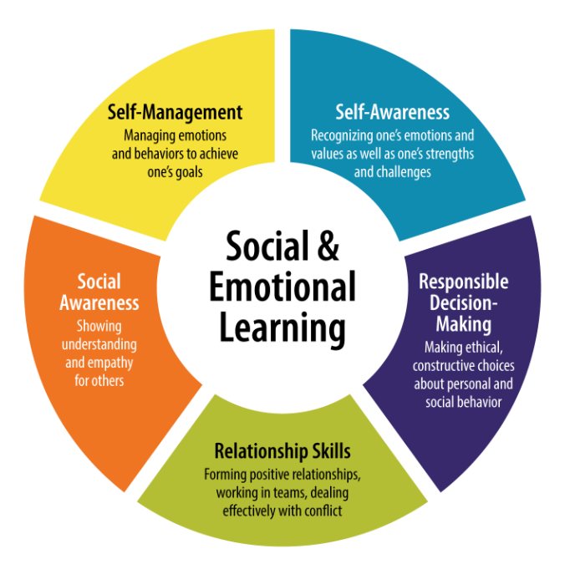

**● Social Awareness:** The ability to take the perspective of and empathize with others, including those from diverse backgrounds and cultures. The ability to understand social and ethical norms for behavior and to recognize family,

school, and community resources and supports.

● **Responsible Decision-Making**: The ability to make constructive choices about personal behavior and social interactions based on ethical standards, safety concerns, and social norms. The realistic evaluation of consequences of various actions, and a consideration of the well-being of oneself and others.

**● Relationship Skills:** The ability to establish and maintain healthy and rewarding relationships with diverse individuals and groups. The ability to communicate clearly, listen well, cooperate with others, resist inappropriate social pressure, negotiate conflict constructively, and seek and offer help when needed

(Core SEL Competencies, 2020)

**THE BENEFİTS OF SEL FOR STUDENTS**

The students will have the 21 st century skills and dispositions that will be equipped with as they prepare for the next steps in life.

**● Content Knowledge** is the teaching of the learning standards and documents. The use of standards to streamline instruction ensures that teaching practices deliberately focus on agreed upon learning targets. Expectations for student

learning are mapped out with each prescribed standard.

**● Communication** is the practice of conveying and receiving ideas quickly and clearly. In a world of global and digital communication, it has never

been more important for students to learn to communicate with clarity, sophistication, persuasion, and conviction.

**● Collaboration** is the practice of working together to achieve a common goal. Careers and jobs require employees to collaborate to address problems and create solutions. Graduates will someday work with colleagues who hold different perspectives and working styles. Collaboration at work demands patience, understanding, and regulation.

**● Creativity** is the practice of using the imagination and divergent ideas to develop new concepts, solutions, and opinions. The 21 st century affords graduates in post-secondary education and the workforce limitless opportunities to seek new solutions, create unknown systems, try new skills, and perceive situations from multiple perspectives.

**● Critical thinking** is the practice of solving problems, finding answers to complex inquiries, and analyzing information. Our 21 st century graduates must be equipped with the ability to verify the validity of information, find truth in differing claims, discern fact from fiction, and ask questions that lead to sound judgment.

**● Character Education** is the teaching of skills and dispositions necessary for being successful citizens, such as caring about others, honesty, controlling emotions, responsibility, and other important traits (Orozco, 2020).

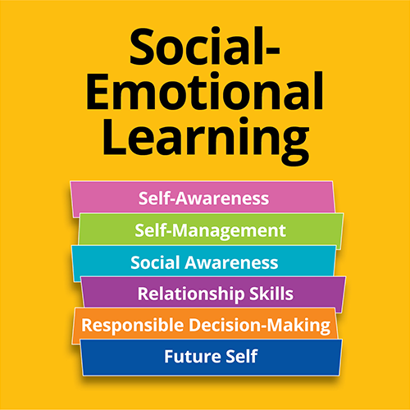

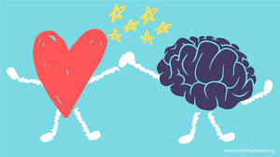

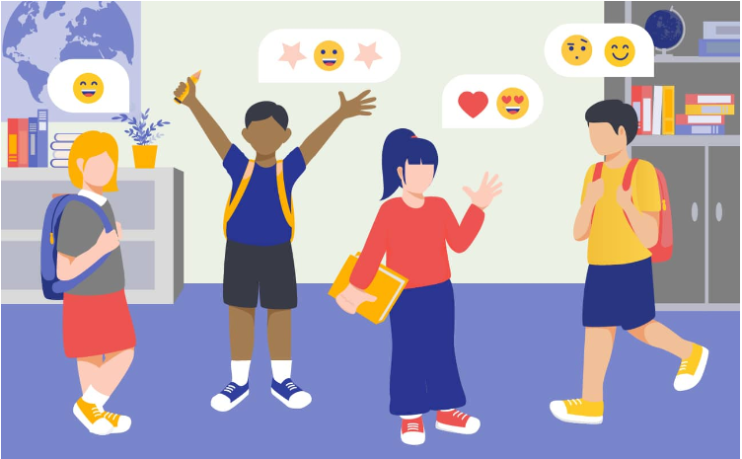

**What is Social-Emotional Learning and Why is it Important?**

**What is Social-Emotional Learning?**

First, it is crucial to define what social-emotional learning is. An [article](https://www.cfchildren.org/what-is-social-emotional-learning/) written for The Committee for Children’s website states that social-emotional learning can be defined as “the process of developing the self-awareness, self-control, and interpersonal skills that are vital for school, work, and life success.”

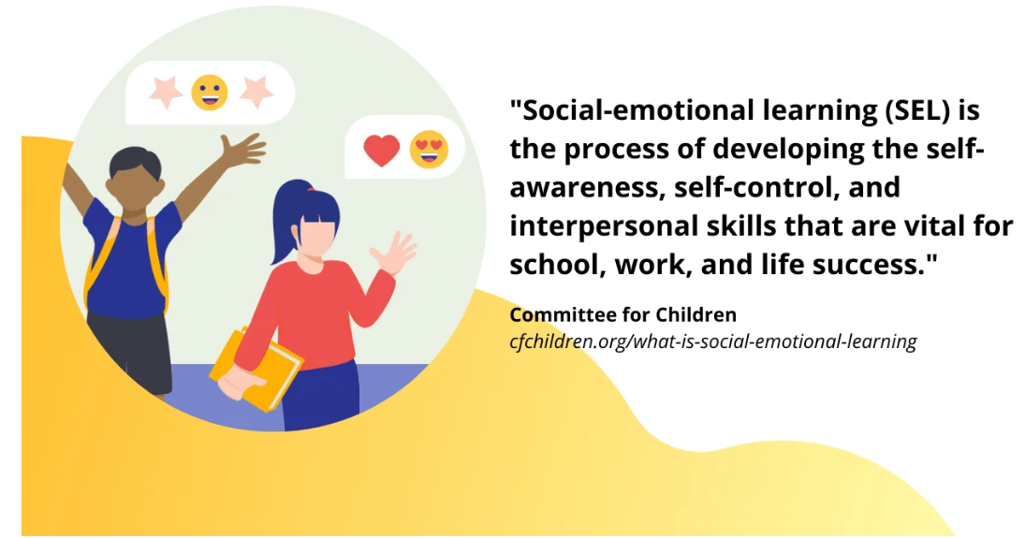

It is a vital part of human development, equipping students with the skills, abilities, tools, and knowledge to build positive relationships, solve problems, make intelligent decisions, and achieve the necessary level of self-awareness. Social-emotional learning can also provide the foundation for educational success.

Moreover, social-emotional learning has a role to play within the context of pushes for inclusive learning and accessible education. As schools embrace people from different backgrounds, who face diverse challenges, students need to understand this and develop empathy and compassion.

**5 Key Social-Emotional Learning Areas**

Understanding the concept of social-emotional learning can be aided by breaking it down into some key areas. Thus, the Collaborative for Academic, Social, and Emotional Learning (CASEL) has created the ‘CASEL 5’ framework, which outlines five core skills or areas associated with social-emotional learning.

The section below explores these five skill areas in greater detail:

**1. Self-Awareness**

Self-awareness is sometimes described as the leading skill in social-emotional learning. CASEL defines it as the ability to “understand one’s own emotions, thoughts, and values and how they influence behavior across contexts.”

A Landmark Outreach article outlines some of the primary skills that are associated with self-awareness. These skills include a student’s ability to recognize and identify their own emotions, develop a perception of “self” which matches reality, believe in their capacity to achieve goals, and determine their areas of strength and weakness.

Additionally, developing self-awareness may require students to reflect on and examine their prejudices and biases and create a mindset that facilitates continuous personal growth. Essentially, for students, self-awareness is about self-reflection and building an understanding of who they are as a person.

**2. Self-Management**

Self-management is a concept closely related to self-awareness, and in many ways, it follows from its development. For example, the CASEL framework describes self-management as the ability to “manage one’s emotions, thoughts, and behaviors effectively in different situations” to achieve personal aspirations.

An overview from Greater Good in Education explores this concept further. It states that self-management is a process that involves students navigating their thoughts, behaviors, and emotions so that they develop an ability to make decisions that benefit not only themselves but also those around them, too.

Some of the primary skills associated with self-management include setting goals, maintaining attention, managing and controlling emotions, demonstrating resilience, and utilizing feedback to make personal progress.

**3. Social Awareness**

The following skill area associated with social-emotional learning is social awareness. An excellent way to think of this is by contrasting it with self-awareness. While the former refers to students’ ability to understand themselves and their actions, social awareness is about becoming more aware of other people and feeling compassion for them.

Social awareness also involves demonstrating empathy and understanding. For example, an article written for Understood.org details some of the skills associated with social awareness. Such skills include the ability to understand the perspectives of others, to appreciate diversity in terms of different backgrounds and cultures.

One of the ways teachers may be able to make students more familiar with the concept of social awareness is by explaining the idea of The Golden Rule, which can be summarized as “treat others the way you want to be treated.”

**4. Relationship Skills**

The fourth main skill area associated with social-emotional learning is the area of relationship skills. Relationship skills can be broadly defined as the ability to build and maintain positive relationships with other people and learning how to communicate with others effectively while resisting negative social pressures along the way.

Part of developing relationship skills is learning to work well with others and achieve shared goals or objectives. A strong focus is also placed on conflict resolution and collaborative problem-solving, which can assist students when asked to work as part of a team or collaborate with a partner.

Furthermore, a significant part of the relationship skills component of social-emotional learning involves developing leadership skills. Instilling such skills not only means developing the skills to lead a group of people to a shared objective, but it also means creating a sense of social justice and being willing to stand up for the needs and rights of other people.

**5. Responsible Decision-Making**

The final main area associated with social-emotional learning is responsible decision-making. This skill can be described as the ability to make ethical, safe, caring, and constructive decisions while remaining mindful of the consequences of personal behavior or the potential outcomes that are likely to emerge from different choices.

Ultimately, the responsible decision-making component teaches students to evaluate their decisions’ potential benefits and consequences. It is also about these skills being applied in and out of school.

One of the aspects highlighted in an article written for Positive Action is that decisions can have social, emotional, physical, and intellectual outcomes or consequences. Another critical aspect is teaching students that positive decisions can lead to growth and positive change, while negative decisions have the opposite effect.

**Why is Social-Emotional Learning Important?**

Social-emotional learning is vital for students because it teaches them crucial life skills, including the ability to understand themselves, develop a positive self-image, take responsibility for their actions, and forge relationships with the people around them. It can also be critical for students to build confidence and self-esteem.

Through social-emotional learning, students can gain the following tools, which are required to set goals for themselves: solve problems, persevere in the face of adversity, fight for social justice, empathize with other people, take responsibility, lead by example, and establish the kind of behaviors that most predict long-term success in modern life.

Meanwhile, social-emotional learning is also helpful for teachers. After all, as a general rule, it is much easier to teach a classroom filled with students who have the following attributes: conscientious, empathetic, self-aware, equipped to make intelligent decisions, and able to reason and give consideration to the benefits and consequences of their actions.

**The Benefits of Social-Emotional Learning**

The importance of social-emotional learning can be explained in a broad sense. However, it is also helpful to provide details on some of the tangible and measurable benefits of the process. Fortunately, research on the topic is emerging all the time, and we can gain a good sense of how advantageous social-emotional learning is.

CASEL compiled [research](https://casel.org/impact/) from around the world, demonstrating that social-emotional learning can enhance academic performance, improve classroom behavior, decrease instances of depression and increase students’ ability to manage stress. In addition, as students move through school and into adulthood, it can reduce poverty, decrease crime and boost social mobility. Other studies have found improvements in areas like reading, writing, and mathematics.

It is also worth highlighting the employment benefits. According to a [report](https://www.cfchildren.org/wp-content/uploads/what-is-sel/docs/world-bank-group.pdf) from the World Bank Group, 79 percent of employers cite social-emotional skills as being the most important qualities for determining the chances of success. Therefore, teaching social-emotional learning can improve long-term career prospects.

**Why should teachers promote Social Emotional Learning (SEL)?**

Childhood and adolescence can be tough. We all can look back at times when we were frustrated, confused, angry, or scared without an understanding of how to process these strong emotions. Young people’s bodies and brains are changing at such a rapid rate, and they are regularly being bombarded with new ideas and influences. As parents, we do our best to help our children navigate through these rough waters, but with new technology and changing ideologies, we don’t always know what’s best to say and do. Being a child looks different today than when we were young. What hasn’t changed however, is that children who are taught to process, [understand and manage their emotions are more equipped to become emotionally intelligent adults.](https://www.edutopia.org/blog/why-sel-essential-for-students-weissberg-durlak-domitrovich-gullotta)

Research tells us that children today are increasingly distracted, under pressure, and anxious both in and out of the classroom. Fortunately, research has also shown that when schools focus on SEL, students show an increase in positive attitudes and behaviors, a sense of purpose, confidence, and empathy. [Their relationships with their parents and peers improve, as well as their academic performance.](https://www.instituteforsel.net/why-sel) Most importantly, children have a decrease in emotional distress.

Quite simply, children who engage regularly with social and emotional learning are more likely to understand what they are feeling, why they feel that way, and how to work through their feelings.

**Social-Emotional Learning vs Teaching Social-Emotional Learning Skills**

Just as there’s a difference between doing projects and project-based learning, there is a similar difference in teaching SEL skills and literacies and SEL as a model or framework.

To clarify, Social-Emotional Learning is not just teaching students ‘SEL skills,’ nor is it a matter of creating academic lessons and units that discuss, explore, or otherwise involve social-emotional concepts, practices, or behaviors. Rather, Social-Emotional Learning is a significant step forward in making ‘school’ more human and whole. It’s less didactic than it is itself (as a model) empathetic for the challenges and opportunities of the increasingly complex lives of children in a modern, hyperconnected world.

Conceptually, this involves ideas like mindset, attitude, cognitive behavior, self-regulation, persistence, empathy, positivity, and rationality.

On a practical level, this involves behaviors like self-monitoring, beliefs about one’s self, setting goals, decision-making, self-care, and the ability to cultivate and maintain healthy relationships with others. Human beings are inherently social organisms (whether by need, instinct, drive, or necessity), and navigating both social interactions and social relationships play a significant role in the well-being of a person over a lifetime (Weissberg & Cascarino, 2013).

The effect of these kinds of ideas and behaviors on academic performance is predictable enough: happy people in healthy relationships embedded in connected communities is conducive to performance in school. This is likely true beyond children and school. As always, there’s the challenge of separating cause from effect but it’s not difficult to imagine that healthy, happy people thrive and people that thrive (in a multidimensional way: in relationships, with their health, financially, etc.) are generally ‘happy.’

**How Project-Based Learning Can Promote Social-Emotional Learning Skills**

Many facilitators of [Project-Based Learning workshops](https://wegrowteachers.com/consulting/project-based-learning/) begin by having participants envision the characteristics of their ideal graduate from their school or grade level.

Educators individually answer the prompt, “What do you want your students to know and be able to do after their year with you?” Then the responses are collected and documented as a whole group.

I myself have done this protocol with thousands of educators across the country from pre-K to college. The results are always the same. Almost the entire list is outside of the curriculum at first glance. Once in a while, something like reading fluently makes the list, but content is mostly missing. Instead, what teachers suggest are **skills**.

Many of the characteristics listed are ‘soft skills,’ a term that I have come to despise. What I have realized is that the characteristics of an ideal graduate are actually social and emotional competencies. After running this protocol with teachers, I now follow it up by showing the[CASEL competencies](https://casel.org/fundamentals-of-sel/what-is-the-casel-framework/) and have them make connections between their ideal graduate goals and the five CASEL categories and their subheadings.

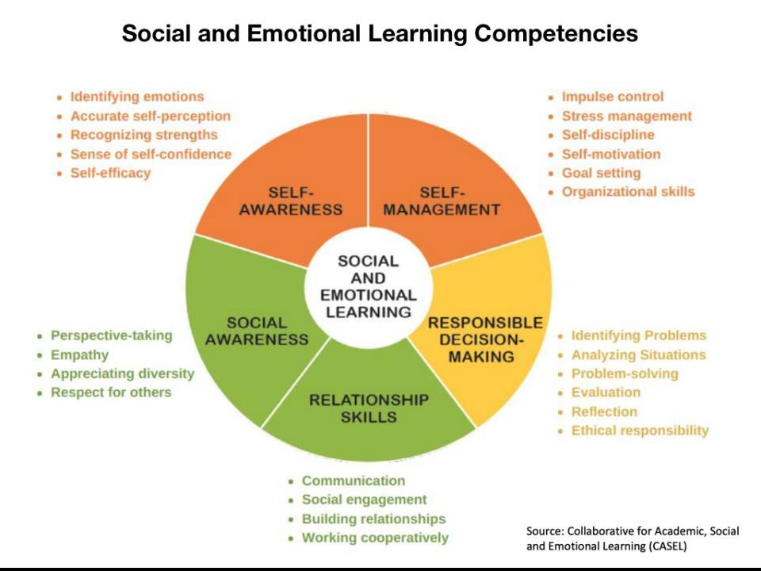

This naturally leads to the question: if these SEL skills are high-priority goals as a school and they mostly fall outside of our content standards, then how do we teach, practice, and assess SEL competencies?

The next question is when do we, as classroom teachers, have time to do this in our already overwhelmingly busy schedule? My answer, of course, is project-based learning. PBL is the perfect structure to teach, practice, and assess SEL skills **and**content standards simultaneously. Let’s consider a few of the ways that students can develop SEL skills while at the same time learning content through PBL.

**Self-Awareness**

A low-hanging fruit example is for students to explore their identity in a project centered on who they are or their role in the community. Adolescents love to explore and share who they are becoming. Identity work is an opportunity for students to discover the connections between seemingly different members of the classroom leading to cohesion and appreciation of diversity.

Over time in a PBL classroom, students develop confidence based on the quality of work that they share and the feedback that they receive through public presentations. Students view themselves as productive members, contributing to the community in powerful ways, ultimately leading to self-efficacy.

**Self-Management**

As students jump into inquiry, they will need to manage the 3 T’s: their time, team, and tasks. [**Robust PBL**](https://www.teachthought.com/project-based-learning/an-updated-guide-to-robust-pbl-for-teachers/) puts students into situations where there will be healthy conflict between team members as they navigate solutions to the project’s dilemmas.

This is an excellent opportunity to provide students with scaffolding and tools to manage deadlines, disagreements, and expectations from community partners. PBL teachers use the Need to Know process, group contracts, scrum boards, and other structures to teach students to address their own challenges rather than organizing everything for them.

**Relationship Skills**

Two of the most important skills that students need today are collaboration and communication. In PBL, students work not only with each other but often with experts from the community. They learn how to give and receive productive feedback to each other. Students present their findings in both written and spoken forms. Communication skills are practiced daily.

Additionally, students learn how to navigate personality challenges and differences of opinion in productive ways. Team members must divide up the work and then share their findings with each other to complete their project tasks. Collaboration is a key element of a well-functioning PBL team.

**Social Awareness**

In PBL, students learn to work together with all different kinds of people, both in the classroom and in the community. Building on the class culture, when developed through identity work, students appreciate that difference can lead to creativity and a valuing of shared humanity rather than divisiveness.

Another skill that can be developed in PBL is empathy. Students must investigate the project challenges from multiple perspectives. They may interview or take on the role of various views in the community. Students appreciate the nuances of an issue by deeply considering how opposing voices have legitimate concerns and opinions.

**Responsible Decision-Making**

Problem-solving is at the heart of PBL. Student teams engage in [Rich Inquiry](https://www.teachthought.com/pedagogy/why-creating-a-culture-of-inquiry-is-important/) to understand the project challenge. They empathetically consider all viewpoints in their proposed solutions. They reflect on potential expected and unexpected results. Students then make real decisions and monitor the results of them.

Students find that they can have a voice in their community and make a difference right now. This leads them back to Self-Awareness as students see themselves as powerful change-makers, building the knowledge and skills to help address and fix needs in their community.

Ultimately cultivating SEL skills in students is a major part of the ‘final product’ of project-based learning.

Of course, students do not come to our classrooms with these SEL skills fully developed, but the PBL framework gives the opportunity for teachers to teach, practice, and assess the competencies naturally throughout the day. [PBL protocols](https://www.teachthought.com/project-based-learning/5-examples-of-project-based-learning-protocols/) and tools enable this process to be smooth and ongoing.

What educators quickly realize is that the SEL competencies listed in the ideal graduate protocol are not separate from the learning curriculum. Instead, they are the requisite skills that empower students to collaborate together in the inquiry process.

So rather than finding time to add SEL lessons, PBL educators discover that teaching SEL competencies throughout the year saves time in classroom management and leads students to deeper learning of their content standards. Most importantly, it helps create the next generation of leaders in this world.

**The promotion of students’ social and emotional learning**

The promotion of students’ social and emotional learning. Educators, parents, and policymakers who recognize that the core SEL competencies are necessary for effective life functioning also know these skills can be taught. Extensive research demonstrates that school-based SEL programs can promote and enhance students’ connection to school, positive behavior, and academic achievement (Durlak et al., 2011). Classroom teachers can help students develop

social and emotional competencies by directly teaching these skills, by using engaging curriculum materials, and by implementing specific instructional and classroom-management practices (Cohen, 2006; Durlak et al., 2011; January,

Casey, & Paulson, 2011; Kress & Elias, 2006; Weare & Nind, 2011; Zins et al., 2004). Some SEL programs teach social and emotional skills directly. Occasionally programs address topics such as substance abuse prevention, violence prevention, health promotion, and character education. Other SEL approaches have specific curricular and instructional components that foster safe, caring, engaging, and participatory learning environments that

build student attachment to school, motivation to learn, and academic achievement (Zins et al., 2004). Recent research has established that the quality of teacher-student interactions and the instructional practices that

take place within the classroom are two important predictors of student academic performance and social adjustment (Hamre & Pianta, 2007; Mashburn & Pianta, 2006). Teacher-focused SEL programs train teachers to be more

emotionally supportive of their students or to use positive discipline practices to respond to students’ needs. These strategies also enhance student skill development (Allen, Pianta, Gregory, Mikami, & Lun, 2011).

**SOCIAL EMOTIONAL LEARNING GOALS:**

**1. Develop self-awareness and self-management skills** essential to success in school and in life. Knowing one’s emotions, how to manage them, and ways to express them constructively are essential life skills. These skills enable one to handle stress, control impulses, and motivate oneself to persevere when faced with personal, academic, or work-related obstacles. A related set of skills involves accurately assessing one’s own abilities and interests, building upon strengths, and making effective use of family, school, and community supports and resources. Finally, it is critical for an individual to be able to establish and monitor one’s progress toward achieving goals whether personal, academic, and career or work-related. These social emotional skills, thought processes, and behavioral strategies cab be contributing factors to one’s self-confidence and sense of optimism as they provide a strong foundation for achieving success in school and in life.

**2. Use social awareness and interpersonal skills** to establish and maintain positive relationships. The ability to recognize the thoughts, feelings, and perspectives of other individuals, including ideas and viewpoints that are different from one’s own, and to empathize with others from diverse backgrounds, is central to forming and maintaining positive relationships at all life stages. Equally important to establishing positive peer, family, and work relationships are strategies and skills that enable one to adapt one’s behavior in various settings, cooperate and collaborate with another person or in a group, communicate respectfully, and constructively resolve conflicts with others

Demonstrate ethical decision-making skills and responsible behaviors in personal, school, and community contexts. The ability to make ethical decisions and behave responsibly, considering the well-being of others as well as one’s own, are essential to benefitting the good of the whole - whether family, peers, colleagues, neighbors, or members of the community at large. It is the foundation of responsible citizenship in a democratic society. Every individual at any stage of life needsthe capacity to make ethical decisions and solve problems by accurately defining the decisions to be made, being able to generate alternative solutions, anticipate the consequences of each, and having the ability to evaluate and learn from the outcomes of one’s decision making.

**SYSTEMIC WHOLE SCHOOL SEL IMPLEMENTATION**

Taking a systemic approach to incorporating SEL into the fabric of school life during and after the

school day requires each school to look at multiple factors (organized into broad categories as

follows, for the sake of clarity):

• SEL integration within policy, procedure and protocols;

• School culture and climate, including building community and tiered support;

• Approach to discipline;

• Instruction;

• Support of Adult SEL needs and competencies;

• Professional development;

• Parent and family engagement; and

• Afterschool, summer school and community school programs

SEL implementation must be predicated on a holistic, whole school approach with socially and

emotionally supported adults able to teach and nurture happy, healthy, safe, and engaged

students. SEL is not just a program or classroom strategy. A holistic approach works with the

entire school community to integrate SEL principles into all facets of school life.

Facilitating school-wide SEL involves multiple components including, but not limited to:

• Aligned district and school support, personnel policies, and practices;

• School culture and classroom environment;

• Supporting adults in the school community (e.g. offering and encouraging self-care

opportunities for all school staff, integrating SEL practices in staff and board meetings,

etc.)

• Professional development for administrators, teachers and other instructional staff,

specialized instructional support personnel (i.e. school counselors, school social

workers, school psychologists, school nurses etc.), non-instructional staff (e.g. school

secretaries, cafeteria staff, school safety personnel, transportation staff, etc.), and staff

from partner organizations;

• Addressing discipline as an opportunity for social emotional growth that seeks

concurrent accountability and behavioral change;

• Outreach to, and engagement of, parents, families, and community;

• Coordination of school, district, and community-based student support services; and

• Aligned afterschool, out-of-school, summer, and extra-curricular and service learning

programs and mentoring.

**SCHOOL CULTURE/SCHOOL CLIMATE AND SEL**

Understanding school climate and culture is necessary for implementing schoolwide SEL. A school climate and culture that is open to and supportive of SEL implementation is necessary to effectively embed SEL into a school’s systems, policies, and procedures. There is an impact on school culture when a school integrates SEL into all facets of school life including explicit lessons,infusion into content area instruction, multi-tiered systems of support, school discipline, supports for adults in the school, and other school policies and practices.

School climate and culture have been defined several ways, and sometimes have been used interchangeably. Today, most educators use the term school climate to refer to the subjective experience of school (how students and staff feel about the school) while school culture is used to refer to the actual state of the school (why they feel the way they do, e.g. shared experiences, beliefs, and values)

A school’s culture is created through the interplay and impact of the values, beliefs, and behavior of all members of a school community, including the influence of the broader community in which the school is located. The type and quality of relationships among and between stakeholder groups, the school’s social norms (what is considered acceptable and unacceptable behavior), and the expectations members have for themselves and for one another, all contribute to a school’s culture. (See Appendix C: What Does a Positive School Culture Look Like?)

SEL implementation can influence relationships and expectations among and between students and adults. It is anticipated that the professional practice of teachers and other school personnel will be enhanced as they teach and model the core competencies. Similarly, as students learn, practice, and share strategies and skills in each of the core competencies, research shows a positive impact on their academic and behavioral growth (better academic performance, improved attitudes and behaviors, and fewer negative behaviors and reduced emotional distress) as indicated by the 2011 meta-analysis previously cited.

It is also important to consider the impact that systemic SEL implementation can have on school climate and culture as members of the school community teach, practice, model, learn, and increase their proficiency in the core competencies

A growing number of districts across the country are adopting systemic strategies that embed SEL into every aspect of school life. Districts are building SEL into their strategic plans and budgets. They are using SEL to help school leaders create the kind of positive school culture and climate that keep students safe and connected to school, strengthen positive teacher-student relationships, and create an environment in which effective teaching and learning can take place. Schools are integrating SEL into classroom instruction as well as providing explicit instruction in the five core competencies. Additionally, SEL is driving collaboration between schools, families, and community partners. Key leaders throughout the district must have the expertise to plan, implement, and integrate SEL throughout their daily work. Districts must develop this widespread capacity including knowledge of SEL theory, research, and practice, across leaders from diverse departments to provide guidance and support for school and classroom SEL development.

CASEL — Collaborative for Academic, Social, and Emotional Learning. (2003). Safe and sound: An educational leader’s guide to evidencebased social and emotional learning (SEL) programs. Chicago, IL: Author.

Cohen, J. (2006). Social, emotional, ethical, and academic education: Creating a climate for learning, participation in democracy, and well-being. Harvard Educational Review, 76, 201-237.

Durlak, J. A., & Dupre, E. P. (2008). Implementation matters: A review of research on the influence of implementation on program outcomes and the factors affecting implementation. American Journal of Community Psychology, 41, 327-350

Denham, S. A., & Weissberg, R. P. (2004). Social-emotional learning in early childhood: What we know and where to go from here. In E. Chesebrough, P. King, T. P. Gullotta, & M. Bloom (Eds.), A blueprint for the promotion of prosocial behavior in early childhood (pp. 13-50). New York: Kluwer Academic/Plenum

Hamre, B. K., & Pianta, R. C. (2006). Student-teacher relationships. In G. G. Bear & K. M. Minke (Eds.), Children’s needs III: Development, prevention, and intervention (pp. 59-71). Bethesda, MD: National Association of School Psychologists

Allen, J. P., Pianta, R. C., Gregory, A., Mikami, A. Y., & Lun, J. (2011) An interaction-based approach to enhancing secondary school instruction and student achievement. Science, 333, 1034-1037.

Zins, J. E., Weissberg, R. P., Wang, M. C., & Walberg, H. J. (Eds.). (2004). Building academic success on social and emotional learning: What does the research say? New York, NY: Teachers College Press

The National Center on Safe Supportive Learning Environments (NCSSLE) maintains a compendium of valid and reliable surveys, assessments, and scales of school climate (https://safesupportivelearning.ed.gov/topic-research/school-climate-measurement) that can assist educators in their efforts to identify and assess their conditions for learning.

& ASCD offers multiple resources on its School Culture and Climate web page (http://www.ascd.org/research-a-topic/school-culture-and-climate-resources.aspx).

The CASEL Guide to Schoolwide Social and Emotional Learning (https://schoolguide.casel.org/).

The CASEL District Resource Center (https://drc.casel.org)

When Districts Support and Integrate Social and Emotional Learning (SEL) (http://www.air.org/resource/when-districts-support-and-integrate-social-andemotional-learning-sel

<https://changingperspectivesnow.org/prek-social-emotional-learning-curriculum/>

https://www.insideoutclub.org/resources/?gclid=Cj0KCQjw6cKiBhD5ARIsAKXUdyaDRN72VXt9D87Zz_FIH10MszxweFLDtF5unVPY1-qVxV9s8KLZH3AaAm5HEALw_wcB