**E-STEAMSEL PROJECT**

**Erasmus+ KA2-** **NO: 2021-1-NO01-KA220-SCH-000032511**

E-STEAMSEL TRAINING PROGRAMME FOR TEACHERS

*Leonardo Da Vinci was on to something years ago when he stated, “Study the science of art. Study the art of science.”*

**Project Identification**

Programme: Erasmus+ Action: Strategic Partnerships for School

Project Title: **E-STEAMSEL Preparing Youth for the Future Labor Market with STEAM and SEL**

Number :**2021-1-NO01-KA220-SCH-000032511**

Project Acronym :E-STEAMSEL

Project Total Duration: 24 months

**Project’s Partners**

 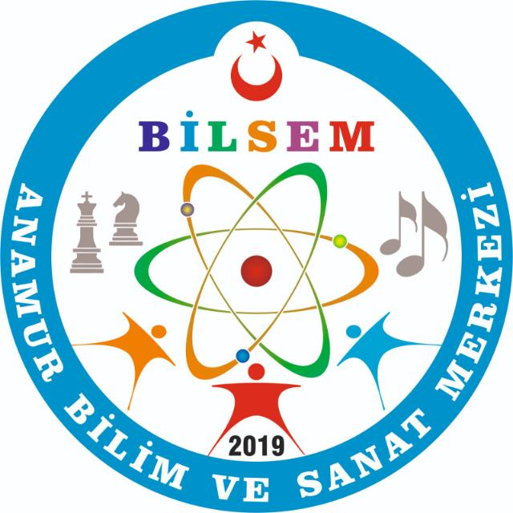

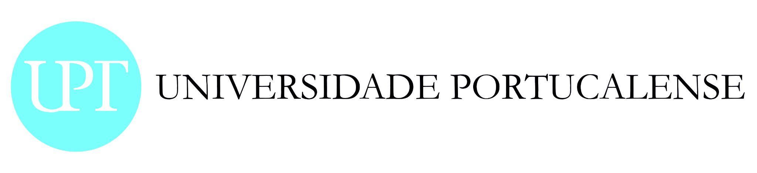

**1.WHY DO WE REQUİRE THE E-STEAMSEL PROJECT?**

Today, knowledge accumulation is growing very rapidly and overflowing beyond the walls of the classroom. Within the education ecosystem; developing analytical, critical thinking and problem solving skills became an important goal in order to become a productive society. We all have a collective responsibility, more than ever, to support the development of today's young people from a holistic perspective for a sustainable economy and society and to prepare them for the 21st century skills-based system.There is a rising momentum all over the world to keep up with the technology revolution.

Today's students will grow to pursue careers that do not yet exist. More than ever, it is necessary to prepare our students today so that they have the confidence to invent the world they want to live in. It is important to equip them with 21st century skills in STEAM (Science, Technology, Engineering, Art and Mathematics) and Social and Emotional

Learning (SEL) (Self-awareness and management, Social Awareness, Relationship Skills, Responsible Decision Making). According to the article of the World Economic Forum titled “New Vision for Education:Promoting Social and Emotional Learning Through Technology'':“People who can cooperate, have high communication skills, can produce solutions to problems with rational methods will be able to exist in the business life of the future. This social and emotional competence equips students to succeed in the evolving digital economy.”Also,UNESCO recently sent a call to schools to implement SEL practices.By 2027, jobs requiring STEAM skills are expected to increase by 13%.EIGE's economic benefits of gender equality study (2017) show that reducing gender discrimination in STEAM education alone leads to 1.2 million additional jobs in the EU. In this context, our aim is to empower teachers, especially girls and secondary school students with multiple disadvantages, in STEAM and SEL areas and to motivate them to use their skills in a wider way. E-STEAMSEL is to give every student the opportunity to learn about technologies and to help them define themselves as innovators and changers who can take an active role in finding solutions to the problems they care about. In addition, to support them to be individuals who are sensitive to environmental problems and have an aesthetic point of view. It is now a necessity for our youth and girls to have STEAM and SEL learning skills in order to take part and struggle in the challenging business world of the future.STEAM mainly focuses on skill development in the fields of science, technology, engineering, arts and mathematics. SEL provides life skills in the fields of teaching and developing the skills needed to manage great emotions, build relationships, gain self-awareness, solve problems, make responsible choices, and set goals. These two complement each other. The world of the future needs individuals with mathematics, science and technology literacy, self-actualization in social and affective learning, creative problem solving and aesthetic values. In this context, our project has adopted the STEAM and SEL fields as a whole and develop them at the transnational level with an e-learning Platform as its main objective is to prepare our students for the digital world of the future.

**WHICH ARE THE OBJECTIVES?**

OUR AIMS ARE TO;

* Ensure creative and meaningful participation of girls and young generation with multiple disadvantages in STEAM and SEL education, preparing them for the future labor market

* Raise and spread awareness and sensitivity among teachers, schools and parents in the field of STEAM and SEL learning

* Ensure inclusion, equality and easy access in STEAM and SEL learning areas, and to raise the skills-based literacy of especially disadvantaged youth and girls to higher levels.

* Provide digital content and digital-skills supported transformation in teaching and learning processes

* Develop practical ideas of how to involve students into the learning activities and create environment in which students can study in an innovative way

* Ensure equal access to project result for both genders

**OUR GOALS ARE TO;**

* Develop a virtual platform as a resource center for practical and innovative learning solutions that complement the curriculum of schools;

* Create a moodle-based e learning platform

* Produce materials for three separate sections on the platform

* Skill-based learning e materials (STEAM)

* Produce Social and Emotional Learning activities

*İnteractive Counseling Services for Parents And Students

The idea of creating and implementing such a tool is the answer to the call for modernity, digitalization, and computerization related to every aspect of life.

**WHO ARE THE USERS?**

The project will target 3 groups:

1. Teachers in Primary ,secondary and hıgh school.

2.Students in primary,secondary and high school.

3. DECISION MAKERS, Policy formulators, NGOs, youth workers and public, school directors, EU authorities.

**WHY THIS TRAINING PROGRAMME?**

Today’s students will grow up to fulfill careers that do not exist yet. Today, more than ever, it is crucial to prepare our students to become future-ready and have the confidence to invent the world they want to live in. To do this, we must equip them with 21st century skills (critical thinking, creativity, collaboration, communication) and STEAM - Science, Technology, Engineering, Art, and Math - knowledge so they can be prepared for future challenges.

More than ever, it is necessary to prepare our students today so that they have the confidence to invent the world they want to live in. It is important to equip them with 21st century skills in STEAM (Science, Technology, Engineering, Art and Mathematics) and Social and Emotional Learning (SEL) (Self-awareness and management, Social Awareness, Relationship Skills, Responsible Decision Making). According to the article of the World Economic Forum titled “New Vision for Education:Promoting Social and Emotional Learning Through Technology”:“People who can cooperate, have high communication skills, can produce solutions to problems with rational methods will be able to exist in the business life of the future. This social and emotional competence equips students to succeed in the evolving digital economy.”Also,UNESCO recently sent a call to schools to implement SEL practices.By 2027, jobs requiring STEAM skills are expected to increase by 13%.EIGE's economic benefits of gender equality study (2017) show that reducing gender discrimination in STEAM education alone leads to 1.2 million additional jobs in the EU. In this context, our aim is to empower teachers, especially girls and secondary school students with multiple disadvantages, in STEAM and SEL areas and to motivate them to use their skills in a wider way. E-STEAMSEL is to give every student the opportunity to learn about technologies and to help them define themselves as innovators and changers who can take an active role in finding solutions to the problems they care about. In addition, to support them to be individuals who are sensitive to environmental problems and have an aesthetic point of view. It is now a necessity for our youth and girls to have STEAM and SEL learning skills in order to take part and struggle in the challenging business world of the future.STEAM mainly focuses on skill development in the fields of science, technology, engineering, arts and mathematics. SEL provides life skills in the fields of teaching and developing the skills needed to manage great emotions, build relationships, gain self-awareness, solve problems, make responsible choices, and set goals. These two complement each other. The world of the future needs individuals with mathematics, science and technology literacy, self-actualized in social and affective learning, creative problem solving and aesthetic values.

For all these reasons, we have prepared a guide that will enable our teachers, who are the cornerstones of education, to be better equipped in the field of STEAM and SEL.

In this context, we expect and hope that more disadvantaged students, girls, school institutions and education centers will integrate STEAM and SEL programs into their education demands with the E STEAMSEL project. We hope to provide them with a starting point and roadmap. Thus, we aim to raise more equipped individuals for the future and to contribute to equipping more individuals with 21st century skills.

In this sense, below you will find introductions about STEAM and SEL learning, methodologies to be used and lesson plan examples.

FRAMEWORK /CURRICULUM FOR 21ST CENTURY LEARNING

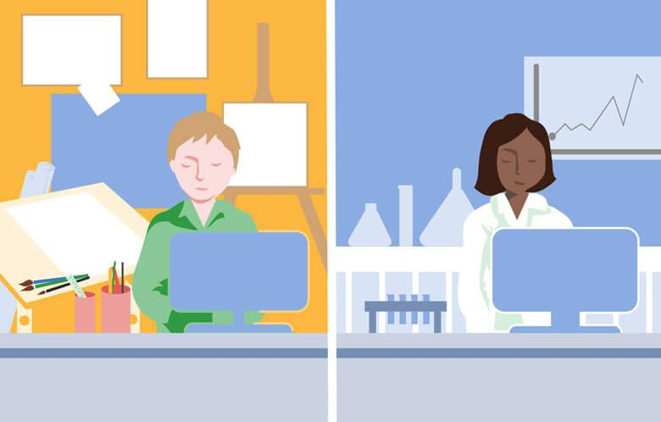

It defines four distinct learning and innovation abilities, focusing on the "4Cs": critical thinking and problem solving, creativity and invention, communication and cooperation. These abilities assist students in preparing for more complicated and unfamiliar job conditions in the future.

To think creatively, students must use a variety of idea generation and brainstorming approaches to generate new ideas, which they must subsequently expand, improve, analyze, and evaluate. And they can't do it alone; creation is rarely attempted alone.

Students must be able to collaborate with others to successfully develop and convey new ideas, be open to alternative viewpoints, and integrate numerous ideas to build more effective and complete solutions to the problems they care about. Most importantly, creativity does not end with the generation of ideas.

Students must be able to act on their ideas, take risks, make mistakes, learn from their mistakes, and continually improve their innovations through a cyclical process of design thinking.

These 21st century skills are the foundations of STEAM education, which is a problem- and project-based approach to learning that incorporates students' hands-on, collaborative, and active participation in solving actual problems they care about.

It is critical to note that the purpose of STEAM education is not to transform every kid into a programmer or engineer. After all, the world need variety. Instead, STEAM education is intended to provide every student with the chance to learn about the technology they use and to assist them in identifying themselves as innovators and change makers capable of actively designing solutions to problems they care about.

STEAM and SEL learning go hand in hand and can be integrated. Therefore, in the 21st century curriculum, schools and education centers have to develop these two skills together. More precisely, they must. Because we can only train today's young people for the business world of the future with a curriculum equipped with these two.

**STEAM Curriculum for teachers**

**Aim of the course:** To present the main concepts and develop the main skills (digital, soft and technical) needed to prepare teachers for STEAM teaching and learning processes and be better equipped in the field of STEAM.

**Target group:** Teachers in Primary, Secondary and High school.

**Curriculum**

1. Understanding STEM and STEAM
   1. Concepts definition
   2. Creating awareness about STEAM education
   3. Most important soft skills for STEAM education: "4Cs": critical thinking and problem solving, creativity and invention, communication and cooperation
   4. Best practices in STEAM education
2. Active learning strategies (ALS)
   1. Definition and main advantages
   2. PBL
   3. Game based learning
   4. Design thinking
   5. Flipped classroom
   6. Technological tools to support ALS
3. How to choose the most appropriate ALS for STEAM
   1. Matching ALS with STEAM skills
   2. How to evaluate in STEAM
4. How can STEAM education work with existing curriculum
   1. Key steps to good STEAM lesson building
   2. STEAM in Primary school
   3. STEAM in Secondary school
   4. STEAM in High school

**HOW CAN STEAM EDUCATION WORK WITH EXISTING CURRICULUM?**

STEAM education allows students to get a deeper grasp of academic disciplines such as arts, mathematics, science, language arts, and social studies. Students will demonstrate what they know, reflect on their understanding and misunderstandings, and share their knowledge with the community via hands-on project-based learning.

What's the bottom line? STEAM activities, when applied meaningfully and effectively, add to students' learning of key subject areas while never detracting from it.

The Invention Cycle has four easy to follow steps that help students solve an engineering or design problem:

1. CREATE: Brainstorm ideas, explore potential materials, and create a first model or prototype.

2. PLAY: Test your prototype to identify what’s working well and what needs to be improved.

3. REMIX: Improve or change your prototype to better solve the problem.

4. SHARE: Communicate your process, ideas and final project.

**What is STEAM?**

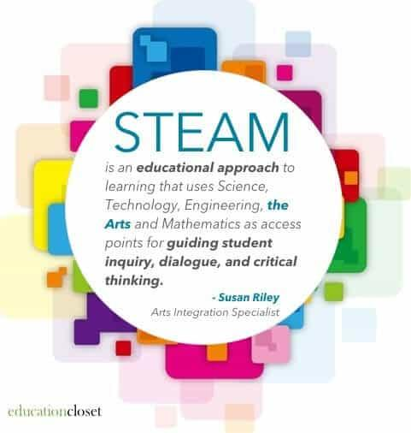

**STEAM Education** is an approach to learning that uses Science, Technology, Engineering, the Arts and Mathematics as access points for guiding student inquiry, dialogue, and critical thinking. In a classroom, a task is considered a STEAM activity when it combines two or more of these two STEAM subjects of study. This approach strives to prompt curiosity, interest and wonder through exploration, discovery and hands‑on learning. It is based on the concept that it is not enough to know about science or maths, or any other subject, but there must be a shift towards actually being able to apply science or maths in a meaningful way. STEAM puts inquiry, creativity and collaboration at the heart of learning

STEAM is an educational discipline that aims to spark an interest and lifelong love of the arts and sciences in children from an early age. Science, Technology, Engineering, the Arts and Math are similar fields of study in that they all involve creative processes and none uses just one method for inquiry and investigation. Teaching relevant, in-demand skills that will prepare students to become innovators in an ever-evolving world is paramount, not only for the future of the students themselves but for the future of the World.

STEAM empowers teachers to employ project-based learning that crosses each of the five disciplines and fosters an inclusive learning environment in which all students are able to engage and contribute. As opposed to traditional models of teaching, educators using the STEAM framework bring the disciplines together, leveraging the synergy between the modeling process and math and science content, for example, in order to blur the boundaries between modeling techniques and scientific/mathematical thinking. Through this holistic approach, students are able to exercise both sides of their brain at once

There is a dynamic synergy between the visual arts and the natural sciences,” according to the article. “For example, science relies heavily on individuals with visual-art skills to render detailed illustrations, depicting everything from atoms to zebras. Likewise, artists apply analytic, linear and logical thinking to compose and scale their work of art.”( Buczynski;2012)

**What is the difference between STEAM and STEM?**

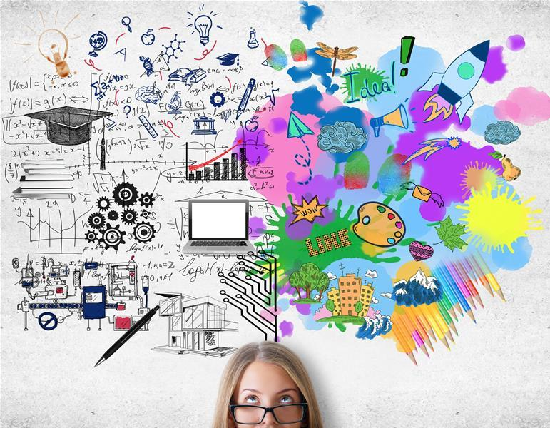

At it’s most basic,**STEM stands for Science, Technology, Engineering and Mathematics**. Alternatively, **STEAM stands for Science, Technology, Engineering, Arts and Math**. But STEM education is far more than just sticking those subject titles together. It’s a philosophy of education that embraces teaching skills and subjects in an a way that resembles real life.

The key component of STEM and STEAM is integration. Instead of teaching disciplines in independent subject silos, classroom lessons are well rounded, project and inquiry based, with a focus on interdisciplinary learning.

STEM and STEAM align with the way we work and problem solve in our daily lives. Making it an exceptional way of instructing and creating a powerful learning environment.

With STEM we are teaching skills the way they will be used in the workforce, and the real world. Rarely does a job require only one skill set like math. Picture an architect, they use science, math, engineering and technology to do their jobs. The subjects do not work on their own, instead they are woven together in practical and seamless ways allowing the architect to design complex buildings.

Jobs in the real world are interdisciplinary. We need to educate children in how subjects integrate and work together. They need to develop diverse skills sets and a passion for exploration and growth. We don’t need children to memorize random facts anymore. We have so many facts at our finger tips now. When I’m having a debate with someone, I can pull out my phone and in seconds have all the facts. Education is no longer about memorizing facts. Instead it is about learning how to think critically and evaluate information. How to apply knowledge, research and skills to problem solve. Skills need to be taught in an applied way, as part of a greater whole, rather than the traditional approach of individual subject silos.

STEM embraces the 4 C’s identified as key in 21st Century education: Creativity, Collaboration, Critical Thinking, and Communication.

**The Benefits of Teaching STEAM Lessons**

**Exposes students to the creative process**

When students engage in activities that combine different elements of STEAM, they experience guided inquiry in which they must ask thoughtful questions, discover answers, apply what they learn, and problem-solve creatively. Students learning how to make a wire sculpture that lights up must ask questions about how it works, try out different wiring techniques to get the sculpture to light up, think about the meaning behind their artistic creation, and experience the creative process, going from a design on paper to a tangible, functional object.

**Offers meaningful collaboration**

Many [STEAM projects](https://resilienteducator.com/classroom-resources/real-world-stem-projects/) involve teamwork and thoughtful dialogue in which students exchange ideas and discuss ways to problem-solve. Through these activities, students learn how to divide up responsibilities, compromise, listen to and encourage each other. Some students might approach STEAM with excitement or curiosity, while others might be more timid or apprehensive.

Strategically placing students together in groups can create powerful teams in which students learn how to help each other and figure out how to use their different strengths and skill sets. If students are learning how to create 3D art depicting sea animals, one student might be knowledgeable about aquatic animals, another might be familiar with optical illusions or excited about constructing 3D glasses. Together, their knowledge, enthusiasm, and skillsets can be utilized to help successfully complete the project as a team.

**Increases critical thinking**

STEAM projects require students to systematically think through problems, applying the information they learn along the way about technology and engineering to figure out the best solutions. Cross-curricular projects also engage different parts of students’ brains so that they are seeing the project through different lenses, focusing on details while also learning to step back and look at the bigger picture.

**Provides a unique way to problem-solve**

American students don’t tend to do as well as students from other countries when it comes to international assessments that measure math, science, and problem-solving skills. STEAM projects give students a chance to problem-solve in unique ways because they’re forced to use a variety of methods to solve problems that pop up during these types of activities. By experiencing trial and error, learning how to take risks, and figuring out how to really “think outside the box”, students get away from the commonly used approach of applying a known method or formula to solve a set of problems in a step-by-step way. With STEAM, they must solve in more creative, non-linear ways.

**Gives all students hands-on learning experiences**

While some students grow up in homes in which they are taught how to build and fix things, and are given many manipulatives to do so, others aren’t exposed to these important learning opportunities. STEAM projects give students a chance to engage in hands-on, experiential learning. Students are often using different materials and tools in order to discover how something works, how to build it, and how to fix it. This levels the playing field so that all students acquire these crucial skills, regardless of their gender, socioeconomic status, or race.

**Encourages girls to explore STEM fields**

Since girls and women are underrepresented in the fields of science, technology, engineering, and math, developing STEAM projects helps girls become familiar with these fields at an early age. Early exposure can increase their chances of exploring these fields further as they get older, and high-quality STEAM projects will still benefit boys as well so that all students are able to acquire these 21st-century skills.

**Shows them a different way to value the arts**

Using art in STEAM projects helps students understand how varied the arts are, and how they’re an integral part of products that involve engineering, technology, and mathematics. The arts can help increase engagement in STEAM projects since students can connect artistic mediums that they enjoy (like visual arts and music) with more technical projects that may seem daunting at first, such as building an app or programming a robot. They’re able to combine the familiar with the unfamiliar, acquiring new skills, and discovering the world of artistic innovation.

**Why STEAM is so Important to 21st Century Education?**

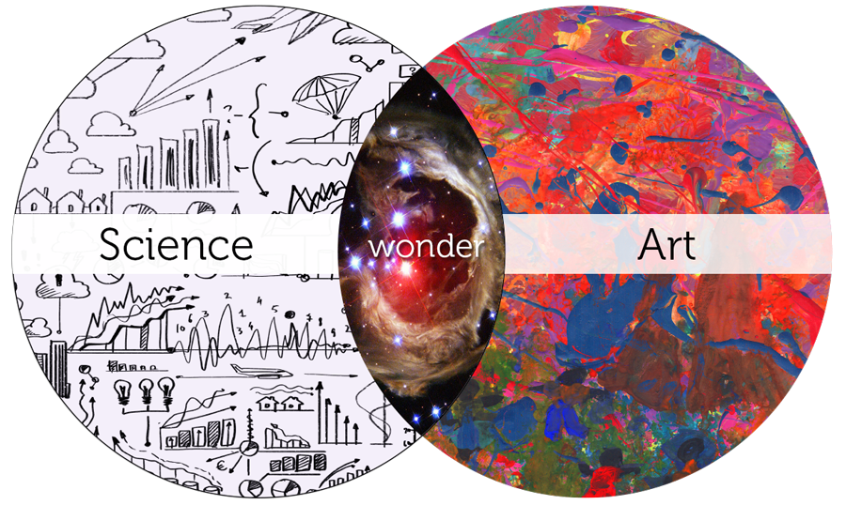

As the education world explores strategies to equip students with the skills and knowledge they’ll need to be successful innovators in a 21st century workforce, there has been a growing emphasis on [STEAM](https://www.steampoweredfamily.com/education/what-is-stem/) — the educational discipline that engages students around the subjects of Science, Technology, Engineering, the Arts and Math.

Many education experts regard STEAM (and its predecessor STEM) as an essential component of 21st century education. In an ever-changing, increasingly complex world, it’s more important than ever that students are prepared to bring knowledge and skills to solve problems, make sense of information, and know how to gather and evaluate evidence to make decisions.Enhancing such skills lies at the heart of STEM and STEAM education.

“Educating students in STEM subjects (if taught correctly) prepares students for life, regardless of the profession they choose to follow,” technology innovator and President of Enterra Solutions Stephen F. DeAngelis says in [an article in Wired](https://www.wired.com/insights/2014/06/stem-success-starts-critical-thinking-problem-solving-skills/). “Those subjects teach students how to think critically and how to solve problems — skills that can be used throughout life to help them get through tough times and take advantage of opportunities whenever they appear.”( DeAngelis;2014)

So says author, futurist and business technology advisor Bernard Marr, writing in [Forbes.com](https://www.forbes.com/sites/bernardmarr/2020/01/15/we-need-steam-not-stem-education-to-prepare-our-kids-for-the-4th-industrial-revolution/#3a5f1d1d55fb) that STEAM education is essential to “prepare our kids for the fourth industrial revolution.” Though we cannot know right now what some jobs of the future will look like, “It makes sense to educate our children with the skills and capacity to think outside the box with creative solutions. This is something a STEAM education can effectively prepare them to do,” he said.

Those subjects teach students how to think critically and how to solve problems — skills that can be used throughout life to help them get through tough times and take advantage of opportunities whenever they appear.”

Those subjects teach students how to think critically and how to solve problems — skills that can be used throughout life to help them get through tough times and take advantage of opportunities whenever they appear.”

Although it is impossible to predict what jobs and lives our learners will face when they are adults, we can help them acquire those key skills needed to thrive in an unknown future. Our learners will most probably need to be able to function in a technological and fast‑changing environment and they will need to know how to…

• apply knowledge and skills to the real world,

• come up with unique solutions,

• create something new,

• re‑design something to improve it,

• overcome challenges,

• explore problems from multiple perspectives,

• direct their own course of action,

• take ownership of tasks, • communicate ideas,

• work collaboratively with others,

• feel safe taking risks.

STEAM helps develop innovative and forward‑ thinking mindsets. These skills provide learners with the tools to be able to apply their learning to an array of challenges in their lives. Individuals who can fall back on patterns of thinking in unfamiliar situations are using their well‑developed habits of mind to understand the world and solve problems skillfully.

**Diversity in STEAM**

Women and minorities have traditionally been under-represented in such science and technology-oriented disciplines such as engineering, mathematics, cybersecurity, data science, STEM and STEAM. Today, many organizations — private companies and government agencies as well as industry advocacy groups — are actively trying to address this inequity.

“It’s no secret that employers are looking for young talent with STEM skills and digital literacy,” Donald E. Bossi, president of FIRST (For Inspiration and Recognition of Science and Technology), writes in an article in [Diversity in STEAM Magazine](https://diversityinsteam.com/2017/12/overcoming-the-stem-opportunity-gap/). “As educators, parents, and business leaders, we have a responsibility to offer all students – especially those who are underserved and underrepresented in STEM – equitable opportunities and pathways to success as contributing members of the workforce.”

[Girls Who STEM](https://girlswhostem.com/) is another online resource focused on ensuring that STEM and STEAM opportunities are available to all.

**HOW TO CREATE A STEAM CLASS?**

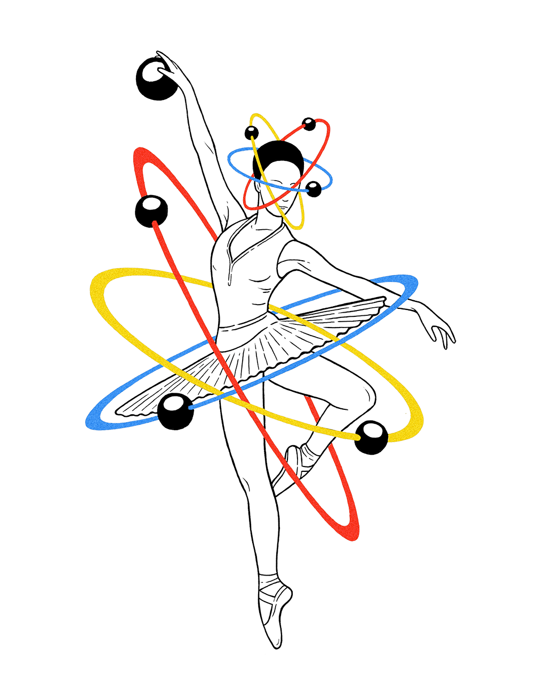

There are actually 6 steps to creating a STEAM-Centered classroom, no matter what area you teach.

**1. FOCUS**

In this step, we’re selecting an essential question to answer or problem to solve.  It’s important to have a clear focus on both how this question or problem relates to the [STEM](https://www.ed.gov/stem) and the Arts content areas you’ve chosen.

**2. DETAIL**

During the detail phase, you’re looking for the elements that are contributing to the problem or question.  When you’re observing the correlations to other areas or why the problem exists, you begin to unearth a lot of key background information, skills or processes that students already have to address the question.

**3. DISCOVERY**

Discovery is all about active research and intentional teaching.  In this step, students are researching current solutions, as well as what ISN’T working based on the solutions that already exist.  As a teacher, you can use this stage to both analyze the gaps your students may have in a skill or process and to teach those skills or processes explicitly.

**4. APPLICATION**

This is where the fun happens!  After students have dived deep into a problem or question and have analyzed current solutions as well as what still needs addressed, they can begin to create their own solution or composition to the problem.  This is where they use the skills, processes and knowledge that were taught in the discovery stage and put them to work.

**5. PRESENTATION**

Once students have created their solution or composition, it’s time to share it.  It’s important that the work is presented for feedback and as a way for expression based on a student’s own perspective surrounding the question or problem at hand.  This is also an important opportunity to facilitate feedback and help students learn how to give and receive input.

**6. LINK**

This step is what closes the loop.  Students have a chance to reflect on the feedback that was shared and on their own process and skills.  Based on that reflection, students are able to revise their work as needed and to produce an even better solution.

**WHAT İS METHODOLOGY?**

**PROBLEM-BASED LEARNING (PBL)**

Problem-Based Learning (PBL) is a teaching method in which complex real-world problems are used as the vehicle to promote student learning of concepts and principles as opposed to direct presentation of facts and concepts. In addition to course content, PBL can promote the development of critical thinking skills, problem-solving abilities, and communication skills. It can also provide opportunities for working in groups, finding and evaluating research materials, and life-long learning (Duch et al, 2001).

PBL can be incorporated into any learning situation. In the strictest definition of PBL, the approach is used over the entire semester as the primary method of teaching. However, broader definitions and uses range from including PBL in lab and design classes, to using it simply to start a single discussion. PBL can also be used to create assessment items. The main thread connecting these various uses is the real-world problem.

Any subject area can be adapted to PBL with a little creativity. While the core problems will vary among disciplines, there are some characteristics of good PBL problems that transcend fields (Duch, Groh, and Allen, 2001):

* The problem must motivate students to seek out a deeper understanding of concepts.
* The problem should require students to make reasoned decisions and to defend them.
* The problem should incorporate the content objectives in such a way as to connect it to previous courses/knowledge.
* If used for a group project, the problem needs a level of complexity to ensure that the students must work together to solve it.
* If used for a multistage project, the initial steps of the problem should be open-ended and engaging to draw students into the problem.

The problems can come from a variety of sources: newspapers, magazines, journals, books, textbooks, and television/ movies. Some are in such form that they can be used with little editing; however, others need to be rewritten to be of use. The following guidelines from The Power of Problem-Based Learning (Duch et al, 2001) are written for creating PBL problems for a class centered around the method; however, the general ideas can be applied in simpler uses of PBL:

* Choose a central idea, concept, or principle that is always taught in a given course, and then think of a typical end-of-chapter problem, assignment, or homework that is usually assigned to students to help them learn that concept. List the learning objectives that students should meet when they work through the problem.
* Think of a real-world context for the concept under consideration. Develop a storytelling aspect to an end-of-chapter problem, or research an actual case that can be adapted, adding some motivation for students to solve the problem. More complex problems will challenge students to go beyond simple plug-and-chug to solve it. Look at magazines, newspapers, and articles for ideas on the story line. Some PBL practitioners talk to professionals in the field, searching for ideas of realistic applications of the concept being taught.
* The problem needs to be introduced in stages so that students will be able to identify learning issues that will lead them to research the targeted concepts. The following are some questions that may help guide this process:
  + What will the first page (or stage) look like? What open-ended questions can be asked? What learning issues will be identified?
  + How will the problem be structured?
  + How long will the problem be? How many class periods will it take to complete?
  + Will students be given information in subsequent pages (or stages) as they work through the problem?
  + What resources will the students need?
  + What end product will the students produce at the completion of the problem?
* Write a teacher's guide detailing the instructional plans on using the problem in the course. If the course is a medium- to large-size class, a combination of mini-lectures, whole-class discussions, and small group work with regular reporting may be necessary. The teacher's guide can indicate plans or options for cycling through the pages of the problem interspersing the various modes of learning.
* The final step is to identify key resources for students. Students need to learn to identify and utilize learning resources on their own, but it can be helpful if the instructor indicates a few good sources to get them started. Many students will want to limit their research to the Internet, so it will be important to guide them toward the library as well.

The method for distributing a PBL problem falls under three closely related teaching techniques: case studies, role-plays, and simulations. Case studies are presented to students in written form. Role-plays have students improvise scenes based on character descriptions given. Today, simulations often involve computer-based programs. Regardless of which technique is used, the heart of the method remains the same: the real-world problem.

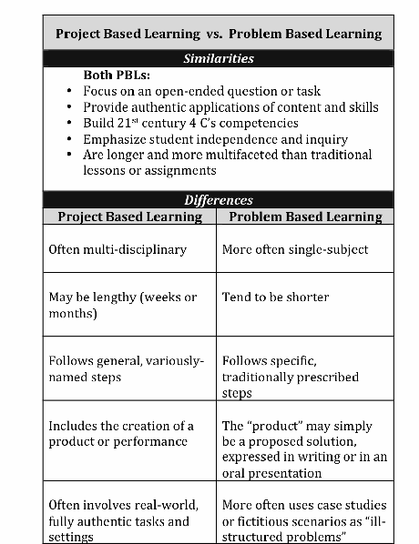

**PBL and STEAM: Do they intersect?**

While there are distinctions between these two approaches, the similarities provide a great starting point to begin a journey towards STEAM problem-based learning

**PBL and STEAM are both process based in process.** PBL places the emphasis on *how* we come to know something, and less on *what* we know. PBL is a shift away from teaching to the test. While it is rooted in standards, it is process, problem, and inquiry based. If students can Google the answer to a problem, it’s not PBL. This process and inquiry is at the very heart of STEAM. PBL employs creative processes like the design process, which naturally aligns to creative processes used in the arts.

**PBL and STEAM are integrative.** In the real world, problems are not divided into content areas or specific lenses, and neither should they be in problem-based learning OR in STEAM. PBLs apply different lenses (economic, social, historical, etc.) to a problem. These various lenses could be from different content areas, but they don’t have to be. Just as with STEAM, to ensure the integrity of a PBL, only naturally aligning contents and lenses should be integrated.

**Let standards be your guide.** Just as in arts integration, where standards must be naturally and authentically aligned to focus learning, standards drive the problem in PBL and STEAM. While process is part of the “big problem,” content is what provides a specific focus. PBL should be assessed on both process and content.

**Maintain the integrity of the “problem.”** The more you parse out a problem-based learning experience among students and/or teachers, the less the kids will have an authentically vested interest in it. Allow students to own the problem and the solution. This means that teachers have to be willing to teach outside of their content specialization when needed. STEAM teachers don’t have to be artists to infuse the arts into an engineering PBL.

**Intersecting the arts and PBL can be a natural fit.** Whether it’s implementing a PBL scenario in the arts classroom or using the arts in a general education classroom PBL, it doesn’t have to be a challenge. The connections should be natural. Arts integration strategies can be utilized in a PBL.

**How do we get started?** It shouldn’t be about problem-based learning all the time- students still need time to learn the fundamentals in all content areas. However, to begin the shift towards PBL and STEAM, we can begin to frame things as “problems” for kids to solve or answer. Rather than the traditional “sage on stage” approach, we can begin with an essential question or problem and give students opportunity to take their learning into their own hands to give them those “4-C” skills they need.

|  |
| --- |
| **KEY STEPS TO GOOD STEAM LESSON BUİLDİNG**  1. Prepare the STEM lesson around a topic you will be teaching.  2. Connect that topic to a real world problem.  3. Clearly define the STEM challenge students will tackle  4. Relate it to the topics and achievements of other courses.  5. Use the engineering design process for planning.  6. 6. Help students identify the challenge  7. Involve students (in teams) in researching the content for the challenge.  8. Encourage teams to develop their own ideas about how to solve the problem.  9. Guide teams to choose one idea to test and then create their prototype.  10. Facilitate the process of prototype testing and evaluation.  11. Involve teams in communicating their findings.  12. Redesign if there’s time. |

|  |
| --- |
| **The key take-aways**   * Provide lots of guidance but few instructions. * Mistakes and design failures are good methods of learning. * The STEM process is not linear – the sequence of events may change. * Students work in teams to solve STEM challenges. * Work with colleagues if possible to write and implement STEM lessons. If it’s not possible, then go for it anyway! |

**STEAM Classroom Resources, Activities & Lesson Plans**

Here is a helpful collection of STEAM education resources designed for use by classroom teachers and others:

* [**Edutopia.org**](https://www.edutopia.org/article/STEAM-resources) includes a collection of articles and videos including [“The Art of Thinking Like a Scientist”](http://www.ascd.org/ascd-express/vol9/909-yokana.aspx) and [“STEM to STEAM: Art in K-12 is Key to Strong Economy.”](https://www.edutopia.org/blog/stem-to-steam-strengthens-economy-john-maeda)
* [**Educationcloset.com**](https://educationcloset.com/steam/steam-resources-for-any-classroom/) (website of the Institute for Arts Integration and STEAM) offers a curated selection of STEM and STEAM articles, including lessons, apps, websites and more.
* [**The Institute for Arts Integration and STEAM**](https://artsintegration.com/ultimate-steam-resource-pack/) offers a free [“Ultimate STEAM Resource Pack”](https://educationcloset.com/ultimate-steam-resource-pack/)
* [**TechLearning.com**](https://www.techlearning.com/tl-advisor-blog/35-resources-for-the-steam-classroom-putting-the-arts-in-stem) offers “35 Resources for the STEAM Classroom: Putting the Arts in STEM.” This post suggests that Leonardo da Vinci was an early adopter of STEAM.
* [**ResilientEducator.com**](https://resilienteducator.com/collections/steam-teaching-resources/) also publishes a comprehensive set of resources geared to “STEAM Teaching for Educators.”
* And some others:

<https://www.steampoweredfamily.com/stem-activities/>

<https://www.steampoweredfamily.com/stem-kits/>

<https://www.steampoweredfamily.com/stem-activities-growth-mindset/>

<https://www.steampoweredfamily.com/water-projects-for-kids/>

<https://www.steampoweredfamily.com/wp-content/uploads/2017/03/Spring-STEM-Activities-2020-SQUARE.jpg>

<https://www.steampoweredfamily.com/summer-stem-activities/>

<https://www.steampoweredfamily.com/fall-stem-activities/>

<https://www.steampoweredfamily.com/winter-stem-activities/>

<https://www.steampoweredfamily.com/science-and-stem-activities-craft-sticks/>

<https://www.steampoweredfamily.com/halloween-stem-activities/>

<https://www.steampoweredfamily.com/halloween-stem-activities/>

<https://www.steampoweredfamily.com/christmas-stem-activities/>

<https://www.steampoweredfamily.com/14-brilliant-stem-activities-for-elementary/>

**Communicating Science Concepts through Art: 21st-Century Skills in Practice** Buczynski, Sandy; Ireland, Kathleen; Reed, Sherri; Lacanienta, Evelyn*Science Scope*, v35 n9 p29-35 Jul 2012

https://www.wired.com/insights/2014/06/stem-success-starts-critical-thinking-problem-solving-skills/

Duch, B. J., Groh, S. E, & Allen, D. E. (Eds.). (2001). The power of problem-based learning. Sterling, VA: Stylus.

* Grasha, A. F. (1996). *Teaching with style: A practical guide to enhancing learning by understanding teaching and learning styles.* Pittsburgh: Alliance Publishers.

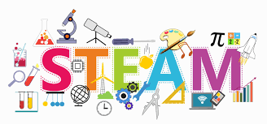

<iframe src="https://app.Lumi.education/api/v1/run/MYDuI4/embed" width="1088" height="720" frameborder="0" allowfullscreen="allowfullscreen" allow="geolocation *; microphone *; camera *; midi *; encrypted-media *"></iframe><script src="https://app.Lumi.education/api/v1/h5p/core/js/h5p-resizer.js" charset="UTF-8" />